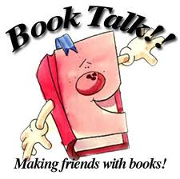

Book Talk Rubric
 | Exemplary - 5 | Proficient - 3 | Incomplete - 1
Complies with best practices for Book Talks:  - Has a “hook” to catch the reader  - Does not give away the ending of the story  - Is the student’s own work | Book talk generally incorporates components of successful book talk tips and models for book talks. | Book talk incorporates some but not all components of successful book talk's tips and models for book talks. | Book talk fails to incorporate a significant percentage of the components of successful book talk’s tips and models for book talks.
Essential information about the book is mentioned during the Book Talk:  title, author,  genre, and publication date | All book talk essential information is included. | The majority of the book talk essential information is included. | Little or none of the book talk's essential information is included.
Script incorporates essential book information-Highlights elements of the book (character, plot, theme, etc.), and presents the material in a manner that will motivate young adult readers. | Script clearly meets all criteria presented in this section. Goes above and beyond. Includes quotes to show the writer’s craft. | Key components of the criteria are absent, but those omissions are judged not to hamper the success of the book talk significantly. | Key components of the criteria are absent, and those omissions are judged to hamper the success of the book talk significantly.
Quality of Presentation | You are a true pro. You were prepared, organized, spoke clearly and articulately, and made good eye contact. Very enthusiastic. | You were somewhat prepared and organized. Pace and volume were mostly good. Sometimes made eye contact. Some enthusiasm. | You were unprepared. Pace and volume need improvement. Limited eye contact. More enthusiasm please.
Total Points Earned

